”… six one thousand, seven one thousand, eight one thousand, nine one thousand---come on you pussy! One more—give it to me! Give me that last one—yeah boy, come on, fuck yeah”
The fucker wasn’t gonna let me off easy, was he? Sometimes I hated him- when he would push me into hating him. This whole Love-hate cycle was driving me up a wall. I wanted what he had to give, I wanted my flabby, out of shape body to look like his. I knew I was stuck with certain traits, my short, stocky body would never conform to, say, the Amazonian body I idealized, that I lusted after.. But this man, my coach had that sort of body; tall, built like a brick shithouse, eyes that could bore right through you and the smoothest, chocolate satin skin stretched taut over his perfectly proportioned frame. Not muscle bound at all but a body that was well trained and beautifully toned. But right now I hated him. Right now he could go straight to hell and I wouldn’t bat an eyelash. Right now, he could go fuck himself!
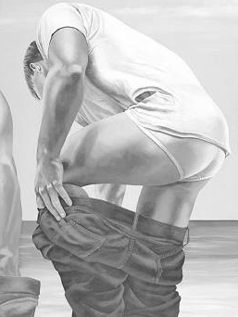

“One more set on the bars, I know you want to give it to me- Let’s go buddy”. I always just melted when he called me buddy- he must have known this as he always ended our sessions by calling me this and I always forgave him for his tirades. On the last set, I was sweatin’ like a pig and I looked up at him spotting me and got an eyeful of his crotch which only made me want to push myself further. I lusted after this man in the worst way and damn if he didn’t know it and use it against me- “you did real good buddy- I’m proud of you and all your work is starting to show” Time to shower up now… hop to it!”
It was difficult to look him in the eye but inside I felt proud of myself and warm all over. As I trudged to the locker room, my legs all rubbery and lightheaded, I opened the door and smelt that moist testosterone as I walked in. I turned the corner to my locker just in time to glance at coach as he bent over to remove his shorts leaving a sparkling white jockstrap framing his beautiful ass. Bent over, I got a great view of his nuts partially escaping the same pouch I salivated over just moments ago….standing up he turned to see me staring at him before I could avert my eyes—gave me a little smile and continued with the unintentional striptease, my heart racing—I’m sure my face was beet red. I stood there slack-jawed as he stripped off his jock, freeing a beautiful piece of manmeat overhanging two incredible, pendulous balls- over ripe and ready for the picking. As he turned to go to the showers, I couldn’t take my eyes off of him until he was out of site.
I looked down at my own crotch which was obviously tented and then to the floor where he had left his jock curled up among his other clothes—beckoning me, inviting me to come take a whiff. I couldn’t help myself- I had to get at it. I carefully made my way to this treasure. As I brought it up to my nose I inhaled deeply almost as I would a drug.
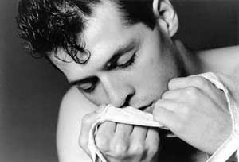
Fuckin A!- This rank, sweaty aroma was everything I expected and more. Intoxicated I fell backwards against the bench, grabbing on my way down a locker door that banged loudly. I heard the shower shut down and coach yelled out “was I okay?”. Gathering myself together I replied that yeah I was okay!”—Panicked I threw down the still warm jock and it landed, sitting there so obvious on top of his other clothes. But it was too late. Coach rounded the corner with a towel wrapped around his waist asking, “what’s up?—Are you sure your okay’ Yeah—I mean yes I’m fine sir I replied. Thank God the panic actually helped me and my boy dick calm down, but not without leaving a noticeable wet spot on the front of my briefs. My face bright red; I looked down at my feet as I continued to pull my sweats up around my thighs. “Aren’t you gonna shower, kid??” he asked. “ No sir- I have to get home fast----uh, I mean soon.”.
His eyes boring right through to my soul, he said, ”Well I’ll tell you what, kid, obviously you are in need of some more intense training, so what do you say we crank it up a notch? You may not like what I have to say at first, but you will thank me in the long run. We are going to be doing something a little different from now on, We will begin and end our workouts in the pool- you will lap swim for 45 minutes both before an after our sessions, as a warm up and cool down. This next thing; I need you to trust me on this one, “I want you to shave tonight when you shower. I want all the hair off your chest, crotch and legs—not a single hair left on your body! Do you hear?” This last thing was said with more authority then a I was use to from this man.. “You can use a little talc tonight after your shower—This will help with the itch. Get a good nights sleep because you are gonna need to be rested for tomorrow. Meet me at 1:30 instead of 3:00. We are gonna get that shag of yours cut off. You are to have your hair cropped at ½ inch on the sides and 1” on the top. You will keep it this way from now on”. He was testing me, I knew it. I was powerless.

What was I willing to give up for this man and for the body I wanted, I craved? I had been working for a couple of years on getting rid of my flabby physique and turning it into a classical marble sculpture before I noticed his ad as a personal trainer, which was just what I needed to go on to the next level. That was months ago and the dedication and discipline he had instilled in me was indeed showing. I was getting a lot of notice by both men and women at work as well as on the street. My shoulders straightened up and I started walking with-not quite a strut- more of a confident stride. This made all the difference in the world, I felt better then I ever had about myself and I wanted this to continue; besides what would it hurt to follow his directions for a time- see what happens.
“..and as for these”- he grabbed the waist band of my briefs, his fingers creeping inside, grazing my piss slit, “ ..you will lose these panties and start wearing boxers like a man” “you will enjoy the feeling of your equipment swaying back and forth as you walk.” He quickly let go and the waistband of my jockeys snapped back and slapped the head of my erect dick, causing a small moan; more like a whimper to escape my throat. He brought his fingers up and licked the precum that had gathered on them.. “Now be a good boy and clean up this mess!”. With that he put on his socks, slacks, shirt-No underwear!-and stormed out into the evening..
I was shocked; stunned. I couldn’t believe what had just happened. It was if he had reached into the dark recesses of my mind, grasped my hidden fantasies and wrung them dry for his pleasure. My mind was reeling. A moment later someone entered the lockeroom and yanked me back to reality. I finished dressing and stuck my things into my backpack and stuffed his stuff into his gym bag. Turning in my key. The receptionist quipped, ”looks like your friend left you a little present” and winked knowingly. I guess he noticed I came in with just my backpack but left with much more. I blushed red hot and I was sure this wouldn’t be the last time.
That night, noticeably shaken, I succeeded in making myself a brief meal. Just a powershake and tuna on rye. Then sat down to watch some tube. Increasingly distracted by my thoughts, after about an hour, I decided to turn the damn thing off. Actually I couldn’t remember anything at all of what I had just watched. I sat for a while in the silence. Just a few years ago, I was doughy, plump, depressed and lacked any real energy at all. Today I had energy plus and thrived on life---actually thrived! In the last year I had decided I needed a little sumpin’ extra from having a trainer and went through a couple before I stumbled on Sam; sorry he wanted to be called Coach, in the want ads. There was something more to him than showed on the outside. He seemed genuine and well rounded. He believed in integrating all aspects of your life including exercise, mental focus, diet and spirituality. He has a certain sadness that made me want to explore his depths. He certainly turned my world around.
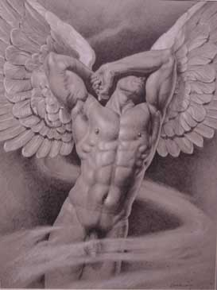
Today, I feel alive and rejuvenated-I feel more comfortable in my own skin and more attuned to my emotions, creativity and fantasies. At least that was what I had thought! As I was thinking, my mind kept going back to that vision of that beautiful dark ass. I wanted to feel it, taste it, feel it. I wanted to dive neck deep into it! My dick sure was needing some attention.
I wondered whether I could do what he had asked of me, I guess more demanded from me. Coach really liked to test my limits and make me reach beyond my grasp. “The only way to grow” he would say. This though was something new, kinda humbling, humiliating, yet exciting. I wasn’t sure if I could do this.
Turning down the living room lights, almost in a trance, I went into the bathroom, stripping off my street clothes and throwing them into the hamper. Coach’s bag fell down from where I had put it when I came in the door. A rush went through me like a warm chill as I stared at the bag. When I unzipped it, the contents fell out onto the tiled floor. I brought his shirt up and sniffed at where his pits had been, the aroma nearly knocking me over from my squatting stance. It was wonderfully heady, unmistakably a man’s odor. I couldn’t keep from frantically grabbing his jock and binging that to my nose too. I loved the smell of this man. I touched it to my lips, my tongue darting out to taste that sweet tang. My mouth by now seriously salivating, it didn’t take much to shove the whole pouch into my mouth. My dick was rock hard and starting to drip again. I brought a fingerfull of my precum to my lips, the same scum he had tasted just hours before. I licked it slowly bridging it from my tongue to my fingertips. I needed this! I needed him… in the worst way!
Gaining some control, I began putting his stuff back in his bag, but there on the bottom of the bag was an small manila envelope with my name, Chris, unassumingly taped to the black bottom, it stood out like a gold ticket in a candy bar, beckoning me. Without too much thought I grabbed it and ripped it open at the seam. What fell out was a link, just a single platinum link of a chain and note that read,
“ IN THE BEGINNING…”

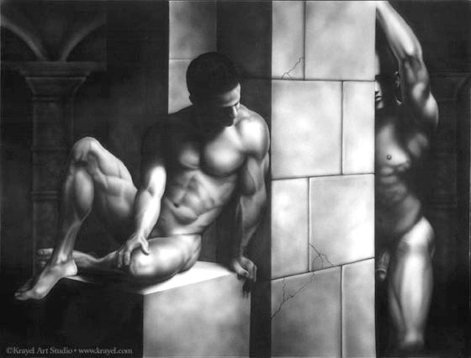

That fucker! He had to have known, the son of a bitch planted this before we even got to the gym today. So fuckin full of himself! Who does he think he is? A wave of fear swept over me, no not fear—more like trepidation for what I thought,(and apparently ) he knew what lie ahead. I’ll show that two can play at this game, I started my bath water getting it a little hotter than would be comfortable and brought out my clippers. I started trimming away, I’ll show that son of a bitch. I used the #1 guard on the clippers and trimmed off all the hair on my chest, pits and pubes. I gathered my tools and stepped into the bath with a 3 pack of disposable razors, a can of shaving cream and a couple of washcloths. Slowly lowering myself into the hot water I soaked for a couple of minutes before beginning what turned out to be an hour and a half procedure. I had done this before for swim team in high school as had a majority of my teammates so it didn’t bother me as much as he probably thought it would. After nicking myself a couple of times I decided to slow down and enjoy the process I started with my legs and went on to my chest, armpits and butt. I started to shave my pubes and stopped short of it. I ended up shaving around my balls and up the shaft of my dick. I left a patch of hair above my dick, kinda a fuck you statement and let the water out of the tubwhich only ended up leaving a mass of stray hairs all over. Steeping back in I got the handheld and sprayed down my body and the tub surround. Using the handheld shower I squatted down and paid particular attention to my ass and balls. The water strumming against them felt incredible.
I got out and dried off thoroughly, opening the bathroom door to let some of the steam out. Wiping down the mirror, I was surprised to see how my body looked after denuding all that hair. My muscles that I had worked so hard at looked more defined. I could see the beginning of a six pack, ( a four pack really) starting to show up. The cleft in my buttcheeks and the shadow of my overhanging chest showed proud and proper. I ran around the apartment buck ass naked for a to try and cool off. The air against my body felt so fuckin good! I wished I had done this earlier. After having snack, I returned to the barthroom and liberally dusted myself with talcum. My skin turned satiny soft and smooth as < you’ll forgive the analogy, a baby’s bottom. I shook off the excess powder and trotted off to bed. I was excruciatingly tired, probably from the workout along with the mental, emotional strain. After setting my alarm. .It didn’t take long for me to drift off to sleep.
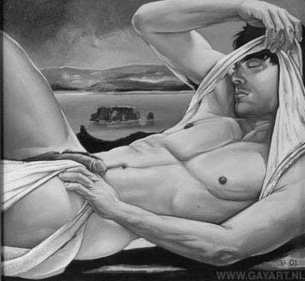

Sometime in the middle of the night I awoke with a fierce hard on, humpin the crisp, cool sheets, fuckin the air with an animal lust. The sheets behind me creeping into the crack of my ass, the ones before me encapsulating my dick like a French whore. My moaning and groaning interrupted only by one word; mantra of sorts. “coach” “please coach”, “ ugh coach!’. I went over the edge bucking the sheets and biting, crying into my pillow. I came with a vengeance, crying out loudly, the white hot slag pulsing out of my dick, into the bed sheets and soaking my belly. “fuck yeah!.Take that you fuckin dickhead”, “ Jesus H Christ! I yes, I cum Fuck!” , fuck yeah ,please I need it!”, I need you!”. My heart was racing, trying to keep up with me and I’m sure that if someone was around to take my blood pressure, I would have blown the circuits in the machine. Holy shit! That felt good!. I got up and blindly sopped up the majority of my spooge with a towel and trudged to the living room with a blanket and my alarm clock in tow. I slept soundly for the rest of the night.
I woke up refreshed and revitalized, drank me a quick cup of brew and tore the sheets off my bed- starchy pile that they were, Stacking them in my hamper along with assorted underwear, socks and shirts. I took a fresh set of sheets out and proceeded to make my bed. Damn, I was in a good mood. I couldn’t just waste away such a beautiful day. I called my friend, Ken, and set up at time to meet with hem for lunch. After dropping my laundry off at my favorite cleaners and doping some shopping, I made my way to Barneys’ our local eatery. Ken knew me like that the back of his hand and it didn’t take him long to fiqure out that something was up. After grilling me for about a half hour, I finally relented and told him my story. “I don’t know what kinda spell this guy has over me but my dick gets half-hard just having him around me.” Ken didn’t offer any suggestions, he wasn’t big on offering suggestions but he was a great sounding board, letting me go on till I was empty. Afterwards, I felt ashamed and excused myself curtly, After all, I had an appointment to keep.
After picking up the two loads of laundry, I arrived early. As I was pulling into the parking lot, I found him there, eyeing his pocket watch. I jumped out of the car, grabbing the laundry and shuffled toward him, shyly watching the sidewalk as I came up to him. With a grunt he directed me to get into his car saying we had somewhere to go and didn’t have much time. I don’t think I I looked at him at all until we came to a stop in front of a barbershop that looked out of place in the middle of this stretch of highrises. The sign outside read “Buzzcuts $15.00”. I looked over at him and he pointed his eyes at the sign then back to my eyes again. Once more a small whimper escaped my throat.
As we entered the shop the barber knowingly acknowledged coach and finished with his client. After the last customer left, he stepped behind him to lock the door and turn the open sign to closed. The barber and coach both led me to a chair without saying a word. The coach told the barber to crop the sides as usual but leave a little length on top. He added “ not so much that I can’t see him sweat”. Little did he know that I was Sweating like a pig under the rubberized cape that thankfully hid my full-blown boner. Coach told me, “ you are to look into my eyes the entire time, boy”. I did as he said, his eyes burning into my soul. My dick twitching and leaking under the cape as the barber shaved my head. The clippers found every erotic nerve on my head. Coach grabbed a handful of my crotch through the material and as he looked at me and I him- he started massaging roughly and continued string right through me. He said,” I know what you did last night, I always know”. His gripped tightened catching my entire kit as he continued, I’m gonna let it go this time, but from now on you are not to cum. Unless and until I say you can!” “ You can beat off and milk that pretty boy dick of yours all you want but you are not to cum, do you understand?”
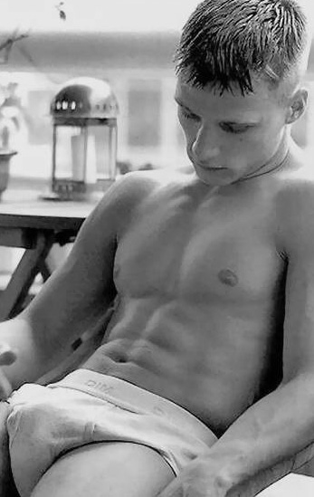
“Yes” was all the breath I could spare with the clippers buzzing my neck, his grip on my wet equipment and those eyes, those damn eyes looking into mine, piercing mine. I was starting to shake from the need, My hips bucking back and forth as much as I dared with the crop job going on on my topside. Trying to get That gripping, fuck yeah, fist oh my God!- Fuck yeah Please daddy, Please let me! I groaned out load and tears started involuntarily leaking from my eyes. Fuck Sir Please!! This went on only a few minutes before he said,” Okay boy, you can cum now” Just then He wrenched my dick hard and the barber dug his hands into my freshly cropped hair. Coach reached up to squelch my moans, covering my mouth and forcing the seed right out of my dick like a firehose. I came violently and asa noisily as I could with his hands covering my mouth. Fuck yeah—I need it Sir-, Please I need to fuck your fist---Yeah holy fuckin Christ!
He never took his eyes off of me- letting go of my mouth I gasped for air. He let go of my kit and I felt a tremendous release and relief; he stood back and gave me one of those half-smiles of his. The barber finished up in a few strokes and ripped the apron right off of me. I was horrified to find in the crumpled folds of my jeans, a huge wet spot That would be impossible to hide. Nodding his head to follow him, he led me through the door. Outside on the way to the car we passed a couple and as they looked down at my crotch I was surprised that along with my shame and humiliation, There was a sense of pride in my stain.
As we drove back in silence, I kept wanting to say something, starting out, “coach, I …oh never mind” trying to get words out but failing at every attempt. Finally as we pulled into the parking lot I blurted out, ”Coach. I just wanted to say how much I appreciate, um, the extra attention” He stopped me before I could continue and His voice lowered an octave and quietly he told me, “look kid, this isn’t about your dick! The sooner you learn this the better! I’m gonna let you go this afternoon, you have a lot to think about but I want you to show up here tomorrow at 1:00 and bring your suit – we’ll warm up in the pool.
As I grabbed my bag from the backseat he said, ”Leave those there with my stuff, now get along and get yourself some rest—you’ll need it”. He got out of the car and I felt privileged that he would do such a thing. Walking toward my car, my sanctuary, he called out, “Stop!”. I turned to look at him palming and playing with some shiny object, making it dance along his fingers like a poker chip. He winked at me as he flipped it through the air. Instinctively I reached up and caught it midair. Looking at this prize I realized it wasn’t a coin at all but another silver chain link, a perfect partner to the one I found last night. Looking back up, he was already in his car and had started his engine; he didn’t even look at me as he drove away. I took my former treasure out of my pocket where it had been stashed and linked the two prizes together. I knew in my heart what they symbolized. I was bewitched, bothered and bewildered. This was how it was that I entered his world.

